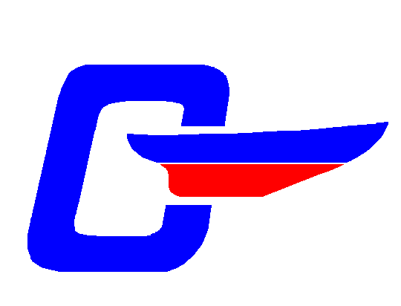
Cape Dory Sailboat Owners Association
~ Chesapeake Fleet ~

GROUND HOG DAY EXTRAVAGANZA
~
SOLOMONS ISLAND, MD ~ FEBRUARY 8, 2003

Dust off the snow, breakout your Spring Commissioning list and your memory book, and get the juices flowing for next season at the Chesapeake Fleet Annual Meeting and Ground Hog Extravaganza. Members of All Fleets are welcome to the Ground Hog Day Extravaganza! Solomons Island is a great place on a sunny day in February.

~ Agenda ~
2:00-4:30 pm – Registration & Sea Stories
2:00-4:30 – CDSOA Chandlery open; Exploration of Solomons, Calvert Marine Museum, antiquing, walk the docks, check out the boats – breath the Bay air and dream of balmy summer breezes
4:30-6:00 – Break from the arduous afternoon activity
6:00-7:00 – Happy Hour (Cash bar and Hors d’oeuvres)
7:00-8:00 – Dinner
8:00-10:00 – Gala festivities and business
~ Chesapeake Fleet Annual Meeting ~
~ Election of Officers ~
~ Changing of the Guard ~
~ Planning for Summer Cruises & Activities ~
~ Sea Chanteys & Nautical Games ~
~~~

Holiday Inn Select – Solomons, Maryland
(800) 356-2009 / (410) 326-6311
155 Holiday Drive
(Call the Holiday Inn directly to reserve your rooms. Specify “CDO”. Room Rates: $89 single; $99 double; Suites: $149-$189.)
~~~
Sunday Brunch for those still standing.
~~~
(Mail in your Reservations today! Call a friend to encourage her (or him) to come. And send an e-mail to the Master Ground Hog that your reservation is in the mail.)

Cape Dory Sailboat Owners Association
~ Chesapeake Fleet ~

RESERVATION FOR GROUND HOG DAY EXTRAVAGANZA

February 8, 2003

Name: _____________________________________ Number in Party: ___________

Telephone No. __________________ E-Mail Address: ________________________

Reserve for Dinner (Indicate number of each entrée desired):

_____ Chicken _____ Beef _____ Seafood

Total number of dinners: _______ x $40.00 == $______________________

(Happy hour cocktails, hotel room, and Sunday brunch are no host.)

Mail completed form with check to Master Ground Hog and Fleet Captain Allen Evans, 11333 Stone House Place, Potomac Falls, VA 20165-5123. (Check payable to CDSOA). Telephone: 703 403-5652. E-mail: adevans@att.net.

