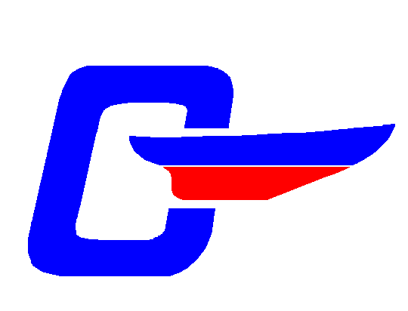 |  |  | Cape Dory Sailboat Owners Association, Inc.  2003 Casco Bay Float-in Registration -- Return by June 1st  July 3-5, 2003 (Hosted By The Northeast Fleet)
Sail Captain: Dave Potts Email david.potts@fairchildsemi.com  Tel. 207-775-4633 |  |  |  |  |  |  | NE Fleet Captain: Michael Heintz Email Mzenith@aol.com  Tel. 203-838-7599
Captain: |  |  |  |  |  |  |  |  |  |  |  |  |  |  |  |  | CDSOA #:
Address:
 |  | Street |  |  |  |  |  | City |  |  |  |  | State |  |  |  |  | Zip
Tel. No.: |  |  |  |  |  |  |  | E-mail:
Boat Name: |  |  |  |  |  |  |  | Model:
Beam: |  |  |  |  |  |  |  | Draft:
State Registration or CG Documentation Number:
Other Identifying Features:
Crew: |  |  |  |  |  |  |  | Crew:
Crew: |  |  |  |  |  |  |  | Crew:
Do you have Crew Berth(s) available for out of area CDers? |  |  |  |  |  |  |  |  | No |  | Yes |  |  | Number available
Boatless? Need a crew berth on a participating boat? |  |  |  |  |  |  |  |  | No |  | Yes |  |  | Number needed:
Shore Point of Contact (has your Float Plan):
Name: |  |  |  |  |  |  |  |  |  | Tel. No.:
Please check any Sebasco Harbor Resorts activities you might be interested in (extra cost: TBD):
 | Group Dinner, Fri July 4th @ Ledges Pub |  |  |  |  | Group Golf (rental clubs available) |  |  |  |  |  |  |  | Camp Merritt: day camp for kids
Captain (signature): |  |  |  |  |  |  |  |  |  |  |  | Date:
An Info Pack will be mailed (or e-mailed) after receipt of completed Registration Form.
Sebasco Harbor Resort Mooring Fees (subject to availability):  Both nights (Thu July 3rd & Fri July 4th) $40.00 (CDSOA # _________) $45.00 (Non-CDSOA)  One night: (Specify either Thu July 3rd $20.00 (CDSOA # _________) $25.00 (Non-CDSOA)  or Fri July 4th  We plan on attending the Raft Up on Saturday Afternoon, July 5th at Snow Island, Quahog Bay (no cost)  2003 CDSOA NE Fleet Rendezvous T-Shirts @ $20/Shirt (After June 1st cannot guarantee T-shirt Availability)  Qty S ______ Qty M______ Qty L ______ Qty XL ______ Qty XXL ______ |  |  |  |  |  |  |  |  |  |  |  |  |  |  |  |  |  |  | $  $  $
Total (check enclosed) |  |  |  |  |  |  |  |  |  |  |  |  |  |  |  |  |  |  | $

Send Registration Form and check made payable to:
David Potts, 14 Line Drive, North Yarmouth, Maine 04097

Please send your registration with payment early as space is limited!

Mooring reservations will be assigned on a first-come, first-served basis as checks are received. A confirmation packet will be sent out upon receipt of your reservation. If no moorings are available, your check will be returned (you are still welcome to attend the raft-up at Snow Island).

