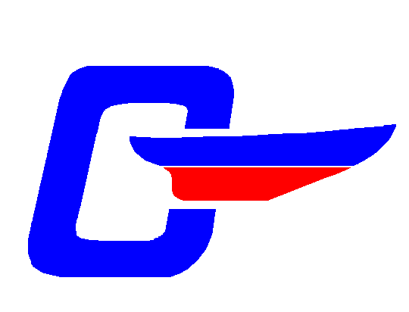 |  | The NE Fleet, CDSOA, Inc.  Winter Meeting 2003 Registration  25 Jan 2003 |  |  |  |  |  |  |  |  |  | Registration:  Leo MacDonald,  macdore@aol.com,  860-859-9600
Unk’s on the Bay
361 Rope Ferry Rd.
Waterford, CT 06385
860-443-2717
Captain: |  |  |  |  |  |  |  |  |  |  |  |  | CDSOA#
Mate:
Address:
Tel. No(s): |  |  |  |  |  |  | E-mail:
Events in which you will be participating (please check applicable boxes):
 | Attending NE Flt Meeting |  |  |  |  | Assist with the Meeting |  |  |  | Committee interest of:
 | Other
Suggestions:
Lunch Selection
Chicken Dijonnaise #; ___ Roast Slice Top Round #; ___ Baked Cod #; ___ |  |  |  |  |  |  |  |  |  |  |  | No Attending: ____
Total Lunch Fees enclosed ($15.75 per person, includes tax and tip): |  |  |  |  |  |  |  |  |  |  |  | Total $ _________
Captain’s signature, or mate if the Capt. can’t write ;-) : |  |  |  |  |  |  |  |  |  |  | Date:

Send Registration Form and Check payable to:
Leo MacDonald, 332 S. Burnham Hwy, Lisbon, CT 06351

 | The NE Fleet, CDSOA, Inc.  Winter Meeting 2003 Registration  25 Jan 2003 | Registration:  Leo MacDonald,  macdore@aol.com,  860-859-9600

Unk’s on the Bay
361 Rope Ferry Rd.
Waterford, CT 06385
860-443-2717

Agenda

10:00-11:00 a.m.: Gam session
11:00 a.m.: Commence Northeast Fleet Winter Meeting
12:30 p.m.: Lunch
2:00 p.m.: Committee Meetings

Lunch

$15.75 per person (including a bottomless pot of coffee during the meeting.)

Menu

Appetizer: New England Clam Chowder (pronounced 'Chow-DA')

Choice of:
Roast Sliced Top Round
or
Chicken Dijonnaise
or
Fresh Baked Cod

With Baby Carrots, Baked Potato, French Rolls, Chocolate Mousse, Coffee & Tea.

Please RSVP by 5 Jan 2002 to:

Leo MacDonald
332 S. Burnham Hwy
Lisbon, CT 06351

