 | CDSOA Northeast Fleet  Wickford Post-rendezvous Float-In  At the Wickford Yacht Club  Pleasant Street  Wickford, RI 02852  401-294-9010  August 5, 2005  4:00-9:00 p.m.  Please register by July 29th
Questions? Contact Event Organizer: Pinkie Sweet-Holland Ph: 401-294-3212. Email: psholland@cox.net
Or Northeast Fleet Captain Cathy Monaghan, Ph: 732-381-3549. Email: c_m_monaghan@comcast.net

Event Information:

The Wickford Post-rendezvous Float-in is being hosted by fellow CDSOA members Pinkie and Bob Holland at the Wickford Yacht Club in Wickford, RI on Friday, August 5th from 4:00-9:00 p.m. The event will be informal with crews gathering on the patio for snacks and conversation but will include a chicken barbecue dinner Friday evening. The patio has gas grills, picnic tables is covered and has side curtains to provide protection from possible inclement weather. We’ll provide the pre-meal snacks, chicken barbecue dinner, and the soft drinks. Please BYOB!

 | 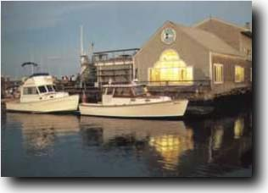  [Figure #1] Wickford Yacht Club.  http://www.wickfordyc.org/
Wickford Yacht Club (401-294-9010) moorings are $30.00 per boat per day and are located approximately 400 yards within the breakwater, in the northern quadrant of Wickford Harbor. The yacht club monitors VHF Ch. 9. Also, Wickford town moorings (401-294-4154 x510) are available for 24 hours at no charge.

Please call and make arrangements for a mooring as soon as possible.

Launch service is available through Brewer's Wickford Cove Marina, also on VHF Ch. 9. The North Kingstown Harbormaster can be reached on VHF Ch. 65 and if you need ground transportation, call 1-800-689-2941 for a taxi.

Yacht Club Guests are welcome to use the first floor accommodations of the clubhouse ONLY: restrooms with showers, outdoor showers, patio tables and trash receptacles. Limited on-street parking is available on first-come, first-served basis.

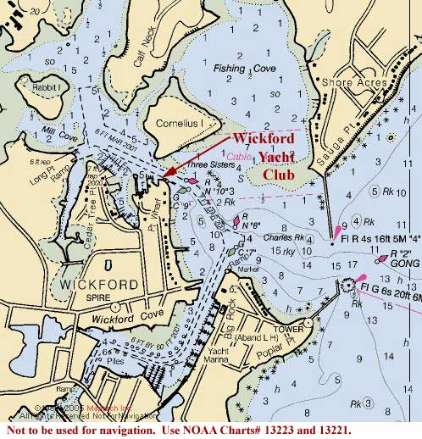
[Figure #2] Wickford Harbor

If you can’t get there by boat, hop in the car (see the Driving Directions at the end of this document).

[NOTE: The fee to cover the cost of food and supplies for the barbecue is $10.00 per person for CDSOA members; $15.00 per person for non-members.]

Please monitor VHF Ch. 16 and 68 for fleet communications.

If you need to contact Pinkie, her home number is 401-294-3212. Pinkie's email is psholland@cox.net. We would like to know ahead of time who will be coming so we can purchase enough food and supplies and can make individual arrangements for special dietary needs, etc., so please print, complete and mail in the registration form by July 29th.

See you at the float-in,
Pinkie and Bob

NOTE: All captains are responsible for their own navigation and for the safety of their crew and vessel.

Driving Directions:

Wickford Yacht Club
Pleasant Street
Wickford, RI 02852
401-294-9010

From points south traveling NORTH on I-95:

Take I-95 North all the way to Exeter, RI.
Merge onto RI-102 S/VICTORY HWY via EXIT 5A toward NORTH KINGSTOWN. (0.8 miles)
Turn LEFT onto RI-102/VICTORY HWY. Continue to follow RI-102. (11.1 miles)
Turn LEFT onto RI-1A/BROWN ST. (0.1 miles)
Turn RIGHT onto MAIN ST.
Turn LEFT onto PLEASANT ST. (0.2 miles)
Street ends with WYC on the Right and Pleasant Street Wharf on the Left
End at WYC.

From points north traveling SOUTH on I-95:

I-95 S toward PROVIDENCE, RI.
Merge onto RI-4 S via EXIT 9 on the LEFT toward NORTH KINGSTOWN. (6.4 miles)
Merge onto RI-102 S via EXIT 5A toward WICKFORD. (3.4 miles)
Turn LEFT onto RI-1A/BROWN ST. (0.1 miles)
Turn RIGHT onto MAIN ST. (0.2 miles)
Turn LEFT onto PLEASANT ST. (0.2 miles)
Street ends with WYC on the Right and Pleasant Street Wharf on the Left
End at WYC.

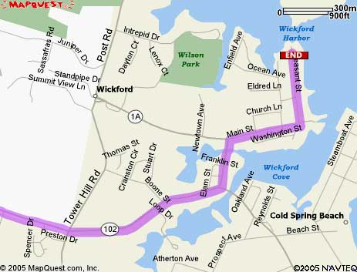
[Figure #3]

 |  | CDSOA, Inc. -- Northeast Fleet  Wickford Post-rendezvous Float-in  Wickford Yacht Club  August 5, 2005  4:00-9-00 p.m.  All Cape Dory owners of both power and sailboats, members and non-member, are welcome to attend. |  |  |  |  |  |  |  |  |  |  |  |  |  |  |  |  |  |  |  |  | Registrar:  Pinkie Sweet-Holland  401-294-3212  psholland@cox.net
Event Organizer: Pinkie Sweet-Holland, e-mail: psholland@cox.net, phone: 401-294-3212 |  |  |  |  |  |  |  | Fleet Captain: Catherine Monaghan, e-mail: c_m_monaghan@comcast.net, phone: 732-381-3549
Captain/1st Mate: |  |  |  |  |  |  |  |  |  |  |  |  |  |  |  |  |  |  |  |  |  | CDSOA#
Address:
 |  |  | Street |  |  |  |  | City |  |  |  |  |  |  |  |  |  |  | State |  |  |  |  |  | Zip
Tel. No(s): |  |  |  |  |  |  |  |  |  |  |  |  | E-mail:
Additional Crew:
Boat Name: |  |  |  |  |  |  | Model: |  |  |  |  |  |  |  | Color (hull/sails):
Hailing Port (indicated on stern):
Other Identifying Features:
Do you have Crew Berth(s) Available for out of area CDers? |  |  |  |  |  |  |  |  |  |  |  | NO |  | YES |  |  |  |  |  | Number available:
Boatless? Need a crew berth on a participating boat? |  |  |  |  |  |  |  |  |  |  |  | NO |  | YES |  |  |  |  |  | Number needed:
(Nice way to meet the rest of the ‘CD world’)
Shore Point of Contact (has your Float Plan):
Name: |  |  |  |  |  |  |  |  |  |  | Tel. No.(s):
Suggestions/Comments:
Entry Fee (per person):
CDSOA members ($10.00) |  |  |  |  |  |  |  |  |  | # of Persons _____ x $10.00 =
Non-CDSOA members ($15.00) |  |  |  |  |  |  |  |  |  | # of Persons _____ x $15.00 =
NOTE: Your registration fee will help to pay for food and supplies for the chicken barbecue. |  |  |  |  |  |  |  |  |  |  |  |  |  |  |  |  |  | Total: |  |  |  |  |  | $
Captain’s (signature): |  |  |  |  |  |  |  |  |  |  |  |  |  |  |  |  |  |  |  |  | Date:

Send Registration Form and Check payable to:
CDSOA Pinkie Sweet-Holland
293 Fishing Cove Road
North Kingstown, RI 02852
Please send your registration by July 29th!

