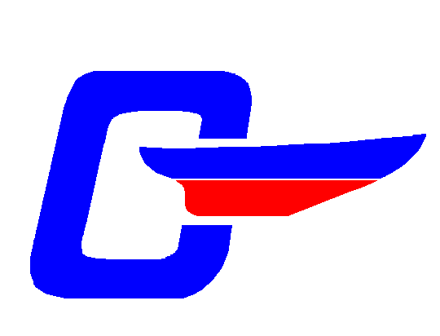 | The NE Fleet, CDSOA, Inc.  Winter Meeting 2004 Registration  29 Jan 2005 |  |  |  |  |  |  |  | Registratrar:  Leo MacDonald  LeoCD33@sbcglobal.net  860-859-9600
Captain: |  |  |  |  |  |  | CDSOA#
Mate:
Address:
Tel. No(s): |  |  |  | E-mail:
Where?
Unk’s on the Bay
361 Rope Ferry Road
Waterford, CT

860-443-2717

http://www.unks.com

Lunch Selection:
Chicken Dijonnaise #: ____  Roast Slice Top Round #: ____  Baked Cod #: ____ |  |  |  |  |  |  |  | Number Attending: ____
Total Lunch Fees enclosed ($11.00 per person, includes tax and tip): |  |  |  |  |  |  |  | $ _________
Registration Fees:  CDSOA Members: FREE Non-Members: $5.00 (per person) |  |  |  |  |  |  |  | $ _________
 |  |  |  |  |  |  |  | Total $ _________
Captain’s signature: |  |  |  |  |  | Date:

Send Registration Form and Check payable to:
Leo MacDonald, 332 S. Burnham Hwy, Lisbon, CT 06351

Please RSVP by January 21, 2005.

Directions to Unk’s on the Bay
From 95 north (From NY): Take exit 72 (Rocky Neck State Park). Take left off exit onto Rt. 156. Follow over Niantic River Bridge, get in left lane, and take left onto West Street. At Sop sign take left, at next stop sign take right and we are located on the right. Additional parking available across street at auto repair station.
From 95 south (From RI): Take exit 81 (Cross Road). Take left at stop sign, get in middle lane to take left at light onto Cross Road and go straight through light. At next light take a right onto Route 1. After fire station on right take a left onto Niantic River Road, follow all the way to stop sign and take a right. We are located on the right. Additional parking available across street at auto repair station.

