 | CDSOA Northeast Fleet  Narragansett Bay Float-In  At the Wickford Yacht Club  Pleasant Street  Wickford, RI 02852  401-294-9010  July 31, 2006  4:00-9:00 p.m.  Please register by July 24th
Questions? Contact Event Organizer: Pinkie Sweet-Holland Ph: 401-294-3212. Email: psholland@cox.net

Event Information:

The Narragansett Bay Float-in is being hosted by fellow CDSOA members Pinkie and Bob Holland at the Wickford Yacht Club in Wickford, RI on Monday, July 31st from 4:00-9:00 p.m.

Fleet communications will be on VHF Ch. 16 and 68.
Please monitor these channels during the event.
Hail “Cape Dory Fleet”.

The event will be informal with crews gathering on the patio for snacks and conversation but will include a barbecue dinner Monday evening. The patio has gas grills, picnic tables, is covered and has side curtains to provide protection from possible inclement weather. We’ll provide the pre-meal snacks, barbecue dinner, and the soft drinks. Please BYOB!

 | 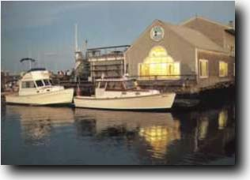  [Figure #1] Wickford Yacht Club.  http://www.wickfordyc.org/
Wickford Yacht Club (401-294-9010) moorings are $30.00 per boat per day and are located approximately 400 yards within the breakwater, in the northern quadrant of Wickford Harbor. The yacht club monitors VHF Ch. 9. Also, Wickford town moorings are available for 24 hours at no charge.

Please call or email Pinkie to make arrangements for a mooring as soon as possible.

Launch service is available through Brewer's Wickford Cove Marina, also on VHF Ch. 9, but it’s best to have your own dinghy. The North Kingstown Harbormaster can be reached on VHF Ch. 9 or 16 and if you need ground transportation, call 1-800-689-2941 for a taxi.

Yacht Club guests are welcome to use the first floor accommodations of the clubhouse ONLY: restrooms with showers, outdoor showers, patio tables and trash receptacles. Limited on-street parking is available on first-come, first-served basis.

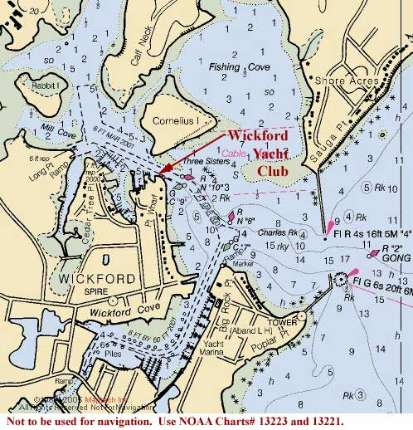
[Figure #2] Wickford Harbor

If you can’t get there by boat, hop in the car (see the Driving Directions at the end of this document).

Fees:

Entry Fee (per person):

CDSOA Members: $10.00
Non-CDSOA Members: $15.00

We would like to know ahead of time who will be coming so we can purchase enough food and supplies and can make individual arrangements for special dietary needs, etc., so please print, complete and mail in the registration form by July 24th.

Any questions regarding this event? Please contact Event Organizer Pinkie Holland at 401-294-3212 or psholland@cox.net.

See you at the float-in,
Pinkie and Bob

All owners of both Cape Dory and Robinhood power and sailboats, CDSOA members and non-members, are welcome to attend.

All captains are responsible for their own navigation and the safety of their vessels and crew.

Use NOAA Charts# 13223 and 13221.

Web Resources:

CDSOA, Inc.: http://www.capedory.org/
Wickford Yacht Club: http://www.wickfordyc.org/

Driving Directions:

Wickford Yacht Club
Pleasant Street
Wickford, RI 02852
401-294-9010

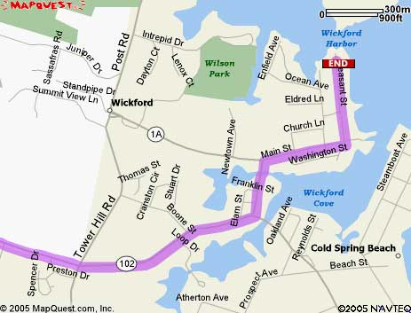
[Figure #3]

From points south traveling NORTH on I-95:

Take I-95 North all the way to Exeter, RI.
Merge onto RI-102 S/VICTORY HWY via EXIT 5A toward NORTH KINGSTOWN. (0.8 miles)
Turn LEFT onto RI-102/VICTORY HWY. Continue to follow RI-102. (11.1 miles)
Turn LEFT onto RI-1A/BROWN ST. (0.1 miles)
Turn RIGHT onto MAIN ST.
Turn LEFT onto PLEASANT ST. (0.2 miles)
Street ends with WYC on the Right and Pleasant Street Wharf on the Left
End at WYC.

From points north traveling SOUTH on I-95:

I-95 S toward PROVIDENCE, RI.
Merge onto RI-4 S via EXIT 9 on the LEFT toward NORTH KINGSTOWN. (6.4 miles)
Merge onto RI-102 S via EXIT 5A toward WICKFORD. (3.4 miles)
Turn LEFT onto RI-1A/BROWN ST. (0.1 miles)
Turn RIGHT onto MAIN ST. (0.2 miles)
Turn LEFT onto PLEASANT ST. (0.2 miles)
Street ends with WYC on the Right and Pleasant Street Wharf on the Left
End at WYC.

 |  | CDSOA, Inc. -- Northeast Fleet  Narragansett Bay Float-in  Wickford Yacht Club  July 31, 2006  4:00-9-00 p.m.  Please register by July 24th |  |  |  |  |  |  |  |  |  |  |  |  |  |  |  |  |  |  |  |  | Registrar:  Pinkie Sweet-Holland  401-294-3212  psholland@cox.net
Event Organizer: Pinkie Sweet-Holland, e-mail: psholland@cox.net, phone: 401-294-3212 |  |  |  |  |  |  |  | Fleet Captain: Bob Emmons, e-mail: bob-emmons@comcast.net, phone: 609-758-7862
Captain/1st Mate: |  |  |  |  |  |  |  |  |  |  |  |  |  |  |  |  |  |  |  |  |  | CDSOA#
Address:
 |  |  | Street |  |  |  |  | City |  |  |  |  |  |  |  |  |  |  | State |  |  |  |  |  | Zip
Tel. No(s): |  |  |  |  |  |  |  |  |  |  |  |  | E-mail:
Additional Crew:
Boat Name: |  |  |  |  |  |  | Model: |  |  |  |  |  |  |  | Color (hull/sails):
Hailing Port (indicated on stern):
Other Identifying Features:
Do you have Crew Berth(s) Available for out of area CDers? |  |  |  |  |  |  |  |  |  |  |  | NO |  | YES |  |  |  |  |  | Number available:
Boatless? Need a crew berth on a participating boat? |  |  |  |  |  |  |  |  |  |  |  | NO |  | YES |  |  |  |  |  | Number needed:
(Nice way to meet the rest of the ‘CD world’)
Shore Point of Contact (has your Float Plan):
Name: |  |  |  |  |  |  |  |  |  |  | Tel. No.(s):
Suggestions/Comments:
Entry Fee (per person):
CDSOA members ($10.00) |  |  |  |  |  |  |  |  |  | # of Persons _____ x $10.00 =
Non-CDSOA members ($15.00) |  |  |  |  |  |  |  |  |  | # of Persons _____ x $15.00 =
 |  |  |  |  |  |  |  |  |  |  |  |  |  |  |  |  |  | Total: |  |  |  |  |  | $
Captain’s (signature): |  |  |  |  |  |  |  |  |  |  |  |  |  |  |  |  |  |  |  |  | Date:

Send Registration Form and Check payable to:

CDSOA Pinkie Sweet-Holland
293 Fishing Cove Road
North Kingstown, RI 02852

Please send your registration by July 24th!

